**KERALA LAW ACADEMY**

**20th NATIONAL CLIENT COUNSELLING (FIRST VIRTUAL) COMPETITION 2020**

**For Justice P. Govinda Menon Memorial Ever Rolling Trophy**

**5th to 7th NOVEMBER 2020**

REGISTRATION FORM

Please read the Regulations of the competition before submitting this registration form.

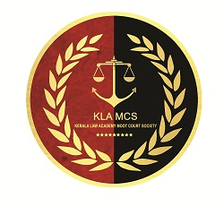UNIVERSITY/ INSTITUTION DETAILS

* Name of University/Institution: ……………………………………
* Address of the University/Institution: ………………………………….
* Telephone No.: ………………….E-Mail: ……………
* Website: ……………………………

DETAILS OF PARTICIPANTS

Please upload a Self-Attested Recent Passport Size Photograph

FIRST COUNSEL

Name: ………………………Gender: …………

Course: ….……………… Year/Semester:…………..

Mobile No: ………………...... WhatsApp No.............

Email: …….……………………………….……

Please upload a Self-Attested Recent Passport Size Photograph

SECOND COUNSEL

Name: ………………………Gender: …………

Course: ….…………………Year/Semester:……….

Mobile No: ………………………. WhatsApp No.............

Email: …….……………………………….……

DETAILS OF THE HEAD OF THE INSTITUTION

Name: ________

Mobile No:

Email:

DECLARATION FORM

1. We declare that the institution and its team members participating in the Competition will abide by all the rules of the Competition set out as and notified to us from time to time through the period of the competition.

2. We also declare and confirm that all the information provided in the registration form is true and accurate.

3. In case of any disputes arising during the Competition, the decision of the committee appointed by the organizing University shall be final and binding and will not be subject to any further deliberations.

Date:

Place: